Secrets Benin Expedition by Fidelia Nimmons
Writing tasks
Writing objectives:
- Identify the audience for writing. (Who am I writing?)
- Use the main features of a type of writing (identified in reading). (What am I writing?)
- Choose effective presentational devices. (How will I write?)
- Organise paragraphs around a theme. (Plan sections.)
- Sequence paragraphs. (Order planned sections.)
- Use a mixture of simple, compound and complex sentences. (Write.)
- Choose effective grammar and punctuation. (Write.)
- Write cohesively at length. (Continuous review: does this writing flow?)

Activities ideas
- Locate and discuss Benin in present day Nigeria.
- Research the reasons for the Benin Punitive Expedition by the British.
- Write a biography of King Ovonramwen who was the king on the throne at the time.
- Discuss reasons why the British wanted control of rubber and palm oil in the Benin Rivers areas.
- List features of pristine rainforest as Emily saw it.
- Write an explanation text on disappearing rainforests of the world.
- Write a letter to Emily when she is in hospital back home. Tell her your views on the behaviour of the soldiers.
- Research and present a video report or podcast on the Benin Bronzes. Use internet images or artefacts from a museum.
- Should the looted Benin Bronzes be returned to Benin? Discuss.
- Paint a picture of the pristine rainforest from one of the scenes described by Emily. Write a short poem about your picture.
- Dramatise favourite parts of this story.
Vocabulary, Grammar and punctuation exercises

Vocabulary work

For each word in the vocabulary list below:
- Give its definition.
- Classify it as part of speech.
- Add a prefix or suffix to it to change its meaning.
- Give two synonyms for it.
- Give two antonyms for it.

Extension:
- Use the word in a reported speech sentence.
- Change your sentence into an indirect speech sentence.
- Write a sentence in the active voice.
- Write a sentence in the passive voice.
- Write a sentence with an expanded adverbial phrase.

Vocabulary
Expedition, punitive, kingdom, village, town, troops, column, scouts, guide, valet, advance, Maxim gun, rifle, surgeon, workshop, auditorium, Agogo bell, lass, bugle, lieutenant, annihilate, tranquil, formidable, dislodge, rocket, execute

Puntuation work
A)
Insert capital letters and appropriate end punctuation where they should go in the sentences below:
1)
this was truly shocking and unnecessary i thought what disgraceful behaviour.
2)
luckily our men were too tired to aim accurately at the benin soldiers the bullets and rockets went astray so no one was killed

3)
i searched around for sam but I could not see him anywhere i wanted him to explain things to me

B)
Write three adjectives to describe the picture below:

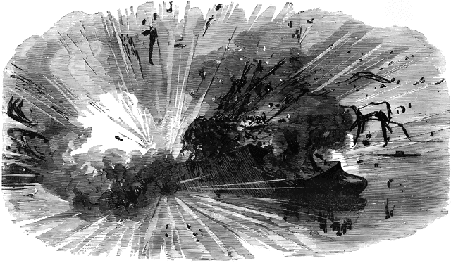

Use your adjectives in a single sentence using appropriate punctuation to make the meaning clear to the reader.

C) Quick composition (Grammar and punctuation)
Look at this picture:
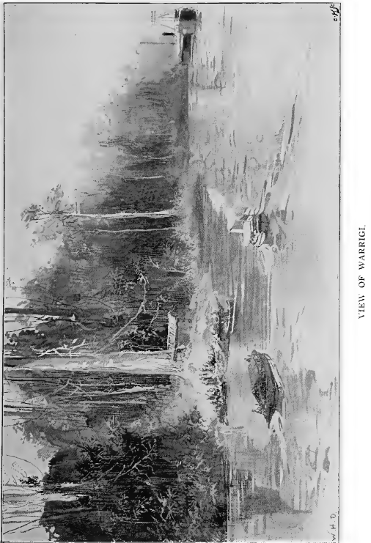
Write a sentence that:
- is a statement
- is a question
- in an exclamation
- contains a relative clause
- uses one semi colon
- uses two semi colons
- contains a pronoun
- contains the verb ‘are’ as a past tense
- uses two antonyms
- uses two synonyms
- has the subordinate clause underlined
- uses an apostrophe as a contraction
- uses apostrophe for possession.

D) Subject and object
- Circle the subject in the sentence below:
Lucy was already standing by Ms. Pritchard waiting to go.
- Change this sentence into its past continuous form.
Circle the object in the sentence below:
We crept silently behind the line of tents to the very last one.
- Change this sentence into its past progressive form.

E) Verb tenses
Change the sentences below into simple present tense
- I wanted to see him once more.
- Mum brought the get-well card and started to read all the messages from my class mates
- I was not listening anymore.

F) Fronted adverbial
Rewrite the sentences below so they begin with fronted adverbials:
- I stopped moving my neck as I had great pain.
- I started to reason with them as I thought that I could get them to change their minds.
- I have so much to tell when I am better.
G) Punctuation
Summarise part 3 of the story using bullet points. You may use conjunctions.

