Queen Mother Idia
cc 1506 – 1550
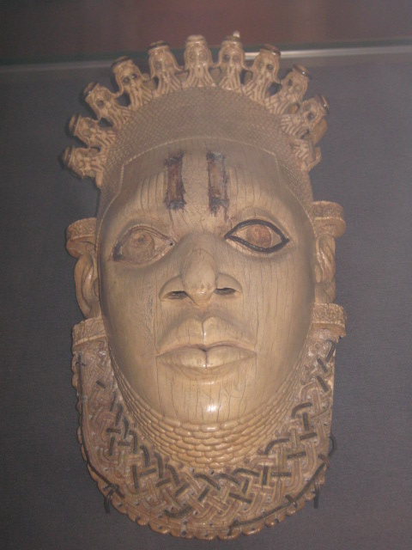
A pendant ivory mask carved in Idia’s honour in the C16

‘Women do not go to war except Idia the mother of Esigie.’ - A Benin saying.

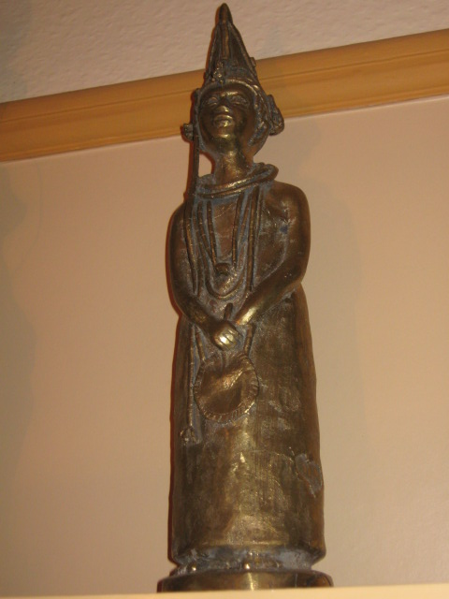
The world’s first Queen Mother
After the death of Oba Ozolua (1481- 1504) a power struggle ensued between his two sons, Prince Osawe who ascended the Benin throne as Oba Esigie and his half-brother Arhuanran who was at that time ruling another powerful town Udo some 20 kilometres outside Benin City. However he ruled as a duke not a king.
Idia is accredited with aiding her son to secure his claim to the throne and for providing him with ongoing support and wise counsel throughout his reign. His kingship survived because of her efforts.
Since the time, they were born, there existed a dispute about who was the rightful heir to the throne. According to Benin tradition, the first born son always succeeds the throne. However, two of the Oba’s wives gave birth to male sons hours apart. As per Benin tradition, the first son to cry is the senior child. Prince Arhuanran was born first by his mother, however, he did not cry out and when a few hours later Prince Osawe was born, he cried out and was reported to the king who performed proclamation rites to declare him heir to the throne. Prince Arhuanran and his mother were unhappy and continued to dispute this position of the rightful heir to the throne, claiming denial of Prince Arhuanran’s birthright. So when his father the Oba died, he made a claim on the throne.
This led to a long and bloody civil war, on record as one of the bloodiest wars in the kingdom’s history. The king’s mother concerned about survival of her son’s monarchical authority and of Benin kingdom, supported him to launch a full scale war on Udo. Oba Esigie won.
The Udo wars led to the defeat of his rebel half-brother and extension of Benin Kingdom domain. Benin royal army built military camps (Eko) on their way to their many war campaigns which were often over long distances. Frequently on their way back from the war, some of the leaders chose to settle down in these camps and not return to Benin. From the Udo wars originated new settlements amongst them Eko (now Lagos) and Ondo. These are now Yoruba lands.
Exploiting weaknesses in the kingdom during this civil war, Igala people sent soldiers across the Benue River to colonise northern parts of Benin kingdom. A long and bloody war ensued Benin Royal troops assisted by Portuguese mercenaries defeated the Igala people (1516).
Here a Portuguese has been casted in Benin Bronze plaque with his matchlock gun. The Portuguese mercenaries trained Benin Royal army and assisted in many Benin wars.
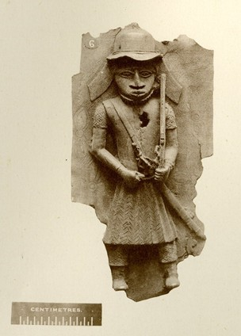
Idia is credited with using her knowledge of magical powers and medicinal knowledge to lead the troops when they fought and pursued the Igala soldiers from the kingdom. 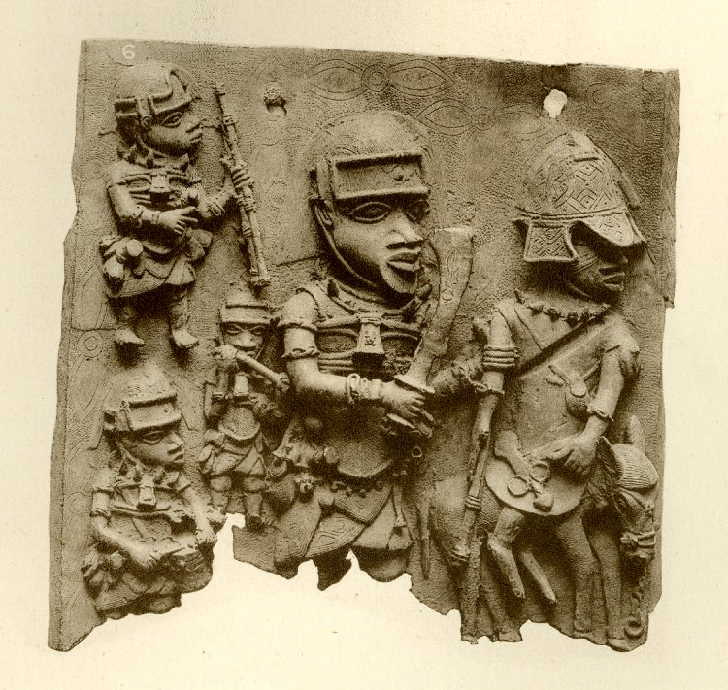
The Igala king was captured and taken to Benin, where he pledged annual tribute to Oba Esigie for the transgression.
The majority of the Igala soldires were lost during the war, a handful of them managed to escape by jumping into the Benue River and swimming across. As the Benin soldiers could not swim to go after them, they got away.
Captured in war kings were brought back to Benin to pledge annual tribute as vassals to the kingdom.
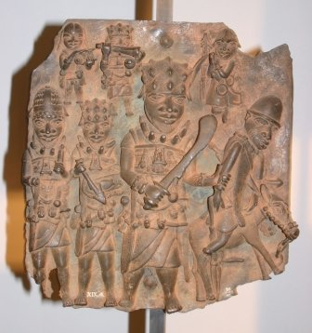
With security and peace in the kingdom, Oba Esigie was able to direct his attention to other matters. He expanded Benin territory. He established Christianity in the kingdom and exchanged ambassadors with the king of Portugal. He received explorers like John Affonso d'Aveiro.
Oba Esigie could read and write Portuguese fluently. His heir was educated under the Portuguese education system.
In honour of her support, Oba Esigie created the title of Iyoba (Queen Mother) granting her equal authority to that of a senior town chief (these chiefs help the king run the towns).
He built a palace for her Eguae-Iyoba at Eselu (lower Benin). Eguae-Iyoba translates as Queen Mother city. From here, she exercised a lot of political influence in the administration of the kingdom as she had her own domain. This arrangement avoided conflict with the Oba’s authority. She had the power to nominate worthy citizens for conferment of special Queen Mother Palace titles.
Oba Esigie commissioned a brass head which represented her to be made and placed on her alter following her death.
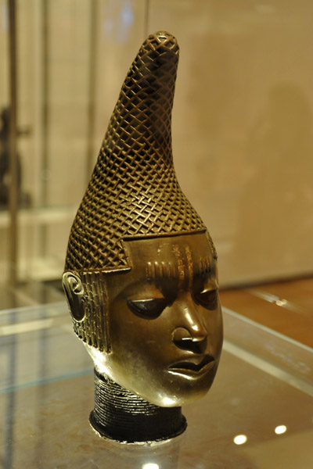
From this period onwards, shortly after the coronation of an Oba, the title of Queen mother is conferred on his mother.
All Queen Mothers are buried in a special burial place in Eguae-Iyoba.
All queen mothers were viewed as instrumental to the protection and well being of the Oba and ultimately of the kingdom.
Queen Mother Idia has remained an inspirational female role model for subsequent queen mothers and all mothers in the kingdom.
In the old kingdom, Queen Mothers were viewed as special and they devoted their time entirely to raising the next king in accordance with traditions.
As one of the few successful military women in world history, her place is rightfully alongside Joan of Arc (1430) , Samurai Hangaku Gozen (1201) and Boudica Celtic Britain (60AD) to name but a few.
Iyoba (Queen Mother) Timeline
1506 to present
Iyoba {Queen Mother} | Mother Of Oba | Period
Idia | Esigie | About 1506-1550AD
Elaba | Orhogbua | ,, 1550-1578AD
Umelu | Ehengbuda | ,, 1578-1606AD
------ | Ohuan | ,, 1606-1614AD
Eson | Ahenzae | ,, 1614-1661AD
Efeseke | Akenzae | ,, 1661-1669AD
Enahen | Akengboi | ,, 1669-1675AD
Edia I | Ahnkpaye | ,, 1675-1684AD
Ohogha I | Akengbedo | ,, 1684-1689AD
Imarhiaede | Oreoghene | ,, 1689-1700AD
Ewebonoza | Ewuakpe | ,, 1700-1712AD
------ | Ozuere | ,, 1712-1713AD
Iha I | Akenzua I | ,, 1713-1735AD
Ede | Erosoyen | ,, 1735-1750AD
Ohogha ll | Akengbuda | ,, 1750-1804AD
Ose | Obanosa | ,, 1804-1816AD
------ | Ogbebo | ,, 1816-1816AD
Omozogie | Osamwede | ,, 1816-1848AD
Ugiomo | Adolo | ,, 1848-1888AD
Ihaya II | Ovonramwen | ,, 1888-1914AD
Eghaghe | Eweka II | ,, 1914-1932AD
Ariowa | Akenzua II | ,, 1933-1978AD
Aghahowa | Erediauwa | ,, 1978-Date
Source: edoworld.net

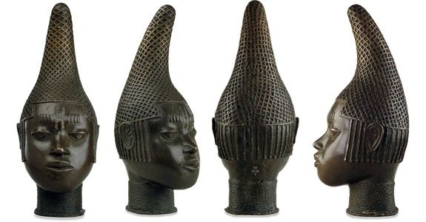
Source: edounionsweden.se

Queen Mother Idia
An inspirational role model for all women
The epitome of motherhood

