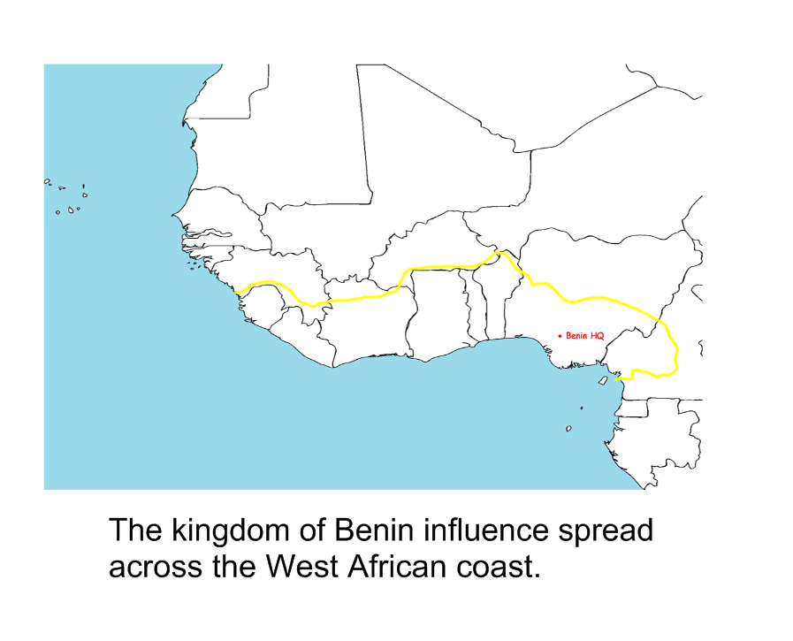

Map of area of Kingdom of Benin influence