The Burning of Benin
February 1897
Activities learning objectives:
History
Aims:
- know and understand significant aspects of the history of the wider world: the nature of ancient civilisations; the expansion and dissolution of empires; characteristic features of past non-European societies; achievements and follies of mankind.
Learning objective: to learn about a non-European society that provides contrasts with British history –Benin (West Africa)
English
Aims:
- To read widely for information,
- To write for a variety of purposes and audiences,
- To use discussion in order to learn,
- To become competent in the arts of speaking and listening; making formal presentations.
Geography
Aim:
- To develop contextual knowledge of the location of globally significant places – both terrestrial and marine – including their defining physical and human characteristics and how these provide a geographical context for understanding the actions of processes.
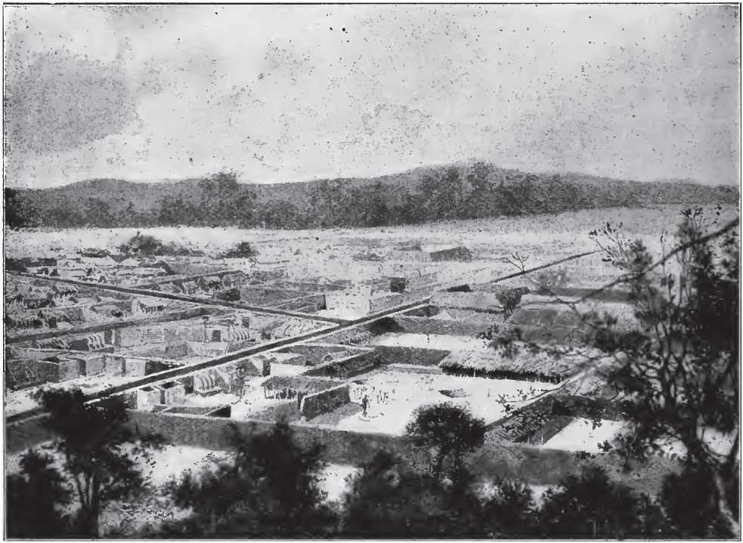
An illustration of Benin by H.C Seppings Wright after its destruction in the Punitive Expedition. This was published in the Illustrated London News on March 27th 1897
Activity 1: Look at this image.
- The thatched roofs have been completely burnt down, trees are charred however the mud houses frames still stand.
- Why do the mud houses not burn during British shelling and burning of Benin City? Use evidence from the diary extracts page 1 paragraph 2 to give 3 reasons for this.

Activity 2: Read this caption for the image: The last shell of a city.
Give 2 reasons in your opinion why this caption is correct or incorrect. Compose another caption for the image.
Activity 3: Experiencing the fire.
-This fire started at 4pm. It was past the hottest part of the day and the evening just setting in. Cool breeze was blowing.
-Captain Bacon wrote a diary about the fire. Why is his diary an important source of information about what happened?
-Look at paragraph 1 page 2. What things did the soldiers save from the fire?
-What one thing would you save if a fire suddenly breaks out in your home?
-Imagine that you had been present at this scene. Write down as many adjectives as you can to describe the fire.
-Use your adjectives to write a poem.
-Use R. Bacon’s description of the fire on pages 2 – 3 to paint a picture of the raging fire.
-Travel back in time and imagine that you are one of the Benin people hiding in the forest when the fire breaks out. Write a diary entry of your thoughts and feelings watching helplessly as your city and homes burn down.
-Imagine you are one of the British soldiers, write the story of an item that you managed to save. Why did you save that particular item, where did you store it for safe keeping, when did you go back for it? What was the reaction of the other soldiers when they saw it?
-Captain Bacon stated that destruction of mud houses was difficult. Imagine that the houses had been made out of wood, write down an alternative description to paragraph 2 page1.
-What do the materials the Benin people built their houses with tell us about their knowledge of science and properties of materials?
Compare and contrast modern Benin City with old Benin City
Modern Benin City
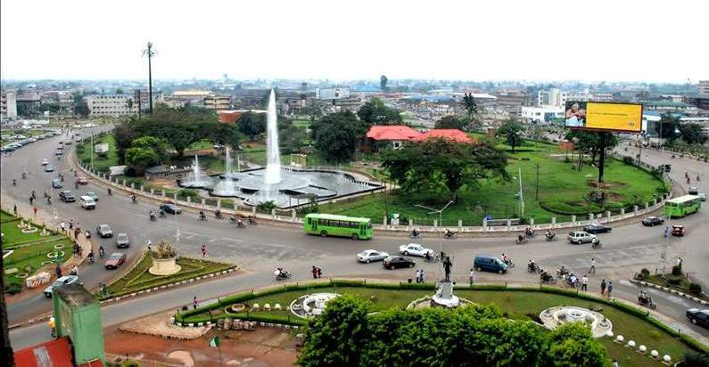

Benin City in 1897
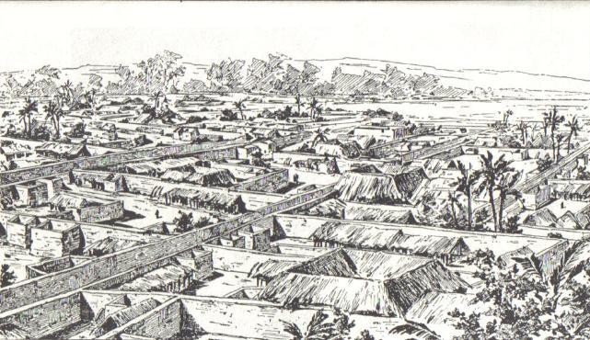
Use the adjectives, adverbial and adjectival phrases from the diary to compose a poem with this title. Here is an example.
Benin Burns
Wildfire,
Raging flames,
Heated air,
Miniature whirlwind of flames,
Blazing fingers of fire,
Air filled with thin black smoke,
Gusts of wind sweeping in every direction,
Curling and wreathing it in fantastic shapes,
Everything seem in a blaze.

Fiery roaring brands swept by the wind,
Missing whole compounds,
Lighting some roof two hundred yards away,
Impromptu cyclone sweeping through compounds,
Fanning smouldering camp-fires into a blaze,
Setting fire to clothes and food in compounds.

The sweeping haze of smoke,
Turning the ground itself,
Into a mighty burning inferno,
Great unbearable heat,
Oozing from the volume of the flame,
Full of finely-divided ash,
From the burning dry thatch,
Irritate the eyes and throat,
Wheezing and coughing abound,
Hell is all around.
Benin is Burning
Benin is burning,
Benin is burning,
Save the bronzes,
Save the bronzes,
Fire, fire,
Fire, fire,
Where are the elders?
Where are the elders?

Benin is burning,
Benin is burning,
Save the bronzes,
Save the bronzes,
Fine art,
Fine art,
Bound for England,
Bound for England.

Discussion
Thousands of Benin Bronze plaques were carted away by the British soldiers. The author does not include this event in his dairy. Discuss plausible reasons for this.

