Bini Creation Story

In the beginning there was no land and only water existed. In the middle of the water stood a tree on top of which lived Owonwon the toucan. Osanobua (The Creator God) decided to populate the world. He wished to send his sons to do so. He summoned his three sons and granted each the choice of a gift to take along.

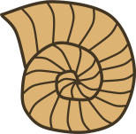
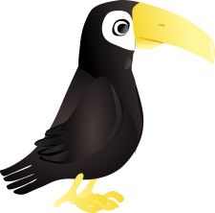
The oldest son chose wealth and the next chose magical skills. As the youngest son was about to make his choice known, Owonwon the toucan cried out to him to request for a snail shell. This he did. The sons then set off on their journey in a canoe. When they reached the middle of the waters, the youngest son turned his snail shell upside down and out flowed an endless stream of sand which formed land from the waters.

The three sons were afraid at first to step onto the land from the canoe for fear of drowning. To test its firmness, they sent the chameleon, who walked cautiously to do so. They saw that the land was firm and good so they disembarked from the canoe.

Osanobua (The Creator God) then came down a chain from the sky, to separate the earth from the waters and to allocate responsibilities to his sons. Osanobua appointed his youngest son ruler of the earth. The son named it (Agbon). Without delay, he set up his headquarters at Igodomigodo.

The eldest son with the gift of wealth was given control of the waters by Osanobua. The Bini call this son, Olokun (meaning the god of the rivers and waters).

The last son was granted freedom to use his magical powers to balance out the negative and positive forces of nature. He was given power over life and death. One side of him is the bringer of death. The Bini named this side Ogiuwu (or Esu the devil). The bloods of all living things belong to Ogiuwu. This means that no living thing can exist forever as Ogiuwu would eventually catch up with it.

Osanobua then settled in the realm of the spirit world across the waters where the sky and the earth meet and there he resides.

While Osanobua and Olokun represent aspects of life such as good health, long life, good luck, prosperity and happiness, Ogiuwu represents mourning, evil omen, diseases and death. The youngest son, the ruler of the earth represents innocence which can be corrupted by the powers of the other forces.

So it was that Osanobua (The Creator God) created a world with good and evil tendencies, and gave man the power of choice between good and bad decisions.

