Benin Civilisation Assembly
Year 4/5 Assembly notes
Durable about 15 minutes. This does not include suggested music playing times.
This assembly for 30 children can be adapted up or down for numbers. It summarises historical Benin Civilization facts.
The assembly play begins with a group of 4 school children using their tablets and laptops to research the civilization a task set for them by their teacher. One of the children hacks into a time travel website which takes them to the year 1472AD and European explorers just landing on the Benin Coast. We see both sides hopeful of a beneficial relationship as a result of the meeting. Accompanying music reveal feelings on both sides and sets the scene for future developments centuries on.
The props for the assembly are simple to make with card, paper or fabric. Children can bring in old white bedsheets from home for use as chiefs’ costume. Keep it simple (see below).
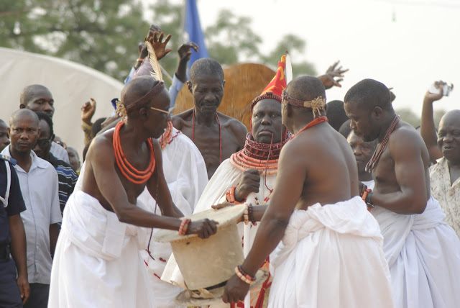

This video below is also useful for ideas on Benin Chiefs and women costumes (starting from 0.29 seconds). Use the same video for teaching the class simple Bini dance moves (from 0.54 seconds).
https://www.youtube.com/watch?v=bOLBwrFfDm4
If it helps, children can read from their research notes instead of memorizing the lines.
For authenticity, flexibility is encouraged with dialogues between the natives. These can be said either in English or the speech cards shown to the audience. Both work perfectly well.
You can find many more activity ideas here: http://www.kingdomofbenin.com/downloads.html
Have fun!

