Teacher: | Class: | Term
Subject: Art and design | Topic/Unit: Benin Civilisation (West Africa)
NC references:  Art: Techniques and use of materials  DT: design, Make, Evaluate  Cross curricula links:  Science: Plant and animal habitats  Geography: The rainforests  http://www.kingdomofbenin.com/downloads.html | know and understand how to:  - improve their mastery of art and design techniques, including drawing, painting and sculpture with a range of materials;  - about great artists, architects and designers in history.  - select from and use a wider range of materials and components, including textiles and ingredients, according to their functional properties and aesthetic qualities

Lesson | Lesson objectives | Teaching sequence | Activity | Plenary | Resources
Week 1 | To improve mastery of drawing techniques –  Pencil and  Charcoal,  To create a drawing from observation  To use a range of drawing materials | Display photo of a Benin Bronze plaques on the IWB. Use one image plaque of the Oba.  Discuss:  What is this?  What material is the plaque made from?  When was it made?  Who is this person?  What features can you see on his face?  What is his skin tone?  Draw out that this is an image of the king in bronze.  Discuss shapes on the plaque: face, neck and head beads: crown, and necklace. | Children to draw plaque image using charcoal and pencil  Draw shape outline with pencil.  Add detail with charcoal.  Use fingers to smudge to achieve detail and effect. | Use mini plenaries to show good examples.  Improve a piece work together, ask:  How can we improve the features in this drawing?  Children to apply improvements suggestions to their own work.  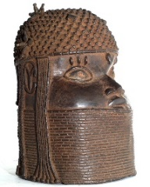 | Bronze plaque photo of Benin king (from Google images).  Sketch books  Pencils  Charcoal  Paper towel  Aprons (optional)  Water to clean hands.
Week 2 | To improve mastery of painting techniques –  Water colour paint.  To be able to develop a painting from a drawing. | Children can paint their drawing from last week or draw new ones.  Ask children:  What do we need to do to add colour to our drawing?  What could we use?  What colours do we need?  Show children | Children paint their drawings using correct brown skin tone and red for king’s beads. | 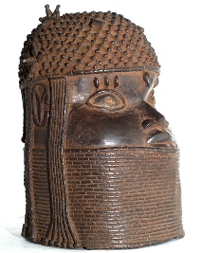  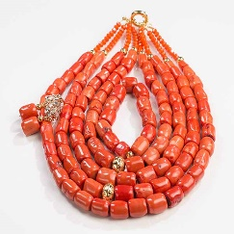 | Photo of Benin beads (Google)  Sketch books  Or sugar paper  Water colour paint  Paint brushes  Paint pots  Water pots  Paper towel  Aprons (optional)  Water  Sink
Week 3 | To improve mastery of painting techniques –  acrylic paint  To add details to painting | AFL question:  Take a moment to look at painting from last week, what needs to be done to make it outstanding?  Model to children to children how to add more detail:  - Paint with the very tip of your paint brush  - use black to make lines sharper | Children use paintbrush as a pencil to paint in detail in wet on dry background.  Start to add details by painting neatly over the top of last week’s work.  Use black pen to make outline stand out. | 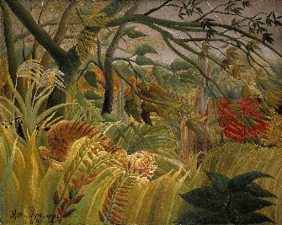 | Painting from last week  Water colour paint  Brushes  Black pens  Paint pots  Water pots  Paper towel  Sink  Aprons (optional)
Week 4 | To learn about the work of great artists in history.  Naïve painter - Henri Rousseau  Tiger in a tropical storm (Surprise) (1891)  Cross curricular link plants and animals of the rainforests | AFL: What does folk art or naïve artist mean?  Inform class we will be learning about Tiger in a Tropical Storm painted by a naïve artist – HR  Watch YouTube video:  https://www.youtube.com/watch  ?v=JQYrBWnJW4s  Research his biography to inspire chn to have a go at painting a jungle scene from their imagination and from observations of photos of Rainforest plants and animals. | Children to produce facts file for:  - H. Rousseau  - Tiger in the Storm facts |  | Internet access  Youtube  Biography website  Pen and paper
Week  5 - 6 | To about the work of great artists in history.  Naïve painter - Henri Rousseau  Tiger in a tropical storm (Surprise) (1891)  Cross curricular link plants and animals of the rainforests | Display the paining on the IWB  Discuss:  What colours can you see in this painting?  What shapes can you see in this painting?  What can you see happening in this painting?  What is the weather like?  What sounds do you think can be heard in this painting?  How does it make you feel?  What is the tiger doing?  Who is at the other end?  Would you like to be in this painting? Why?  Tell children they will be combining the skills they learnt in previous lessons to draw and paint their own version of the painting.  What colours might they use?  How could they make the bright colours- orange shades of green, etc? | Children to spend the next lessons:  - Draw their jungle plants and animal  - Mix colours to paint their drawings of the plants and animal/s  - Apply finishing touches e.g. bold outlines.  Acrylic paint quick facts:  - Are made from thin plastic  - Stick to the small fibers of clothes and dries very quickly so can’t be washed off easily  - Good for outdoor painting | Display children’s drawing as in a portrait gallery. Children to visit each other’s work and leave their comments and feedback on post it notes.  = (what they liked)  ? any questions they have  - 1 Suggestion for improvement | Tiger in a Tropical Storm painting  Sugar paper  Pencils  Pens  acrylic paint  Paint brushes  Paint pot  Water pot  Sink  Paper towel.
Week 7 | To experiment with pulling and fraying fabric  To select from and use a wider range of materials and components, including, textiles and ingredients,  Tie and dye fabric | Show children traditional Benin fabric and cloth.  AFL: How did they manage to achieve the different colours?  How did they get the finishing ends?  Write the words:  Fraying  pulling  Tie and dye  on the IWB and ask what do these words mean?  Show children example of each.  What do the children notice about the tie and dye patterns?  How were these achieved?  Show children examples of use of fraying to create patterns in the edges of cloth.  Give each child a piece of white cloth to fray the edges and then support to tie in different ways. | Pull fibers off their cloth to create different patterns.  Children working individually, experiment with tying the cotton with string in different ways.  When satisfied, dip their cloth in dye solution to soak.  Adult to take these out and dry in a safe place.  Tip: children may leave their cloth unfrayed if preferred. | 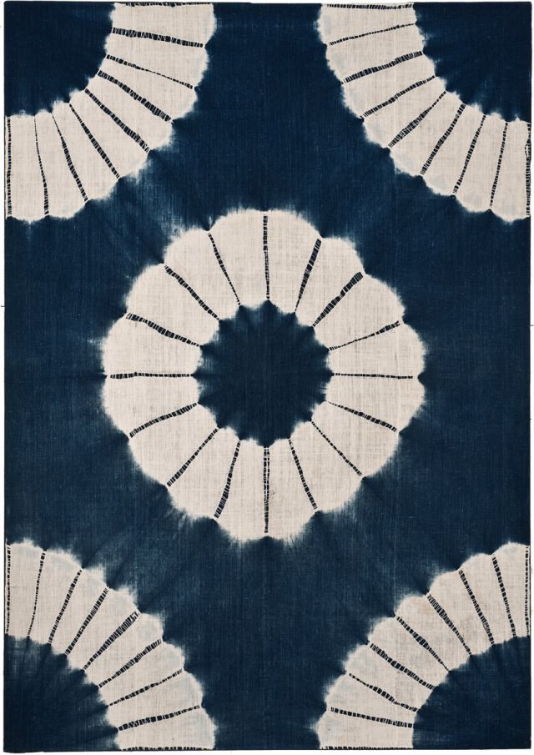  Use mini plenaries to look at progress and for children to have ongoing opportunity to evaluate their products against their own design criteria and to consider the  views of others in order to improve their work. | Hesston or  White cotton cloth  Pins  White Cotton cloth  Different cloth dyes  Water  Thread  Paper towel  String  Pebbles or marbles
Week  8 - 9 | To use different grades of thread and needles.  To learn techniques of sewing- running stitches;  Knitting | Show children how to weave wool to make different shapes and patterns  Show children how to thread a needle  Show children how to do simple running stitches.  Model creating a fabric collage with knitted wool sewn on felt.  Show children African cloth products e.g. fabric purse, bag.  Children could sew their tie and dye material from last week to make a product e.g. a purse. | Weave wool to create different patterns.  Lay on felt and use running stitches to hold in place to create fabric picture.  Completed work can be framed and sent home or displayed in class.  Children could cut and shape their tie and dye fabric into an item e.g. a purse. | 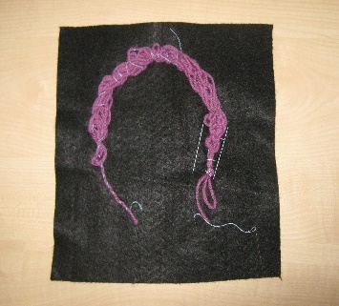 | Knitting Nancy  (optional)  Knitting wool  Sewing thread  Various sized needles  Tie and dyed fabric from last lesson.
Week  10 | To improve mastery of art and design techniques, including sculpture with a range of materials –  Clay | Clay relief, Clay sculpture, Clay modelling  Give children a slab of clay each and show them how to work into a round flat shape.  Use implements like pen covers, pencil tips etc. to create features and impressions on clay to produce e.g. tiger head, cat head, Portuguese faces etc.  Show the class how to make clay sculpture modelling on YouTube videos e.g.:  Play Doh mouse  There are many more tutorial videos on YouTube.  LO differentiation is achieved by complexity of sculpture children are expected to produce. | Children create their clay sculpture on e.g.:  1.On beliefs about the Oba:  - Snake  - Crocodile  - Mudfish  2.Bronze plaques subjects  3. Benin fruit  - Pineapple  - Banana  - Pawpaw etc  4. Clay model of Benin City.  5. Rainforest plants and animals.  6. Clay pots and bowls. | 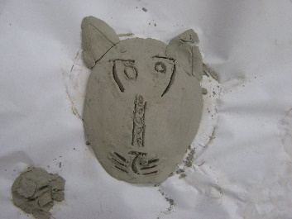  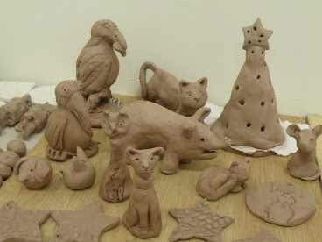  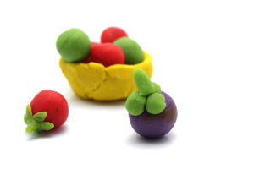 | A slab of clay for each child.  Modelling utensils and children’s fingers and thumbs.  Photos of Benin Royal Palace art.  (Google images)  Click on the YouTube video links below:  YouTube video1  Sculpturing lesson 1
Week  11 – 12 | To improve mastery of art and design techniques, including sculpture with a range of materials –  Paper basket weaving | Collect a good supply of newspaper.  Take one page of a newspaper and cut into four long strips.  Fold each strip into four and then curl to make a rope.  Take 8 paper tubes and place on top of each other in the middle point.  Use tape to hold them in place.  Take the newspaper rope and begin to weave around the paper tubes – over and below  keep doing this using more newspaper ropes as needed.  Soon a basket will begin to form.  Weave your paper ropes around the paper tubes till your basket is finished. | Children weave their paper basket until complete.  Tip: The shape of the basket depends on how hard the paper rope was pulled during weaving.  Challenge  Find a way to weave a paper basket without paper tubes. | 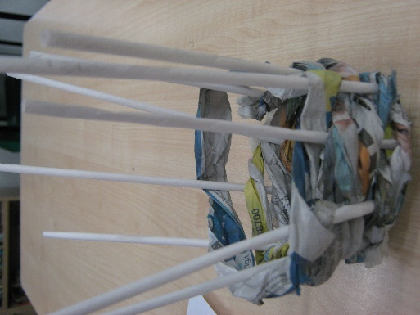 | Masking tape  A good supply of  Newspapers  Paper tubes
Please check the website for many other activities ideas including museum visits and classroom display.

