Public notice

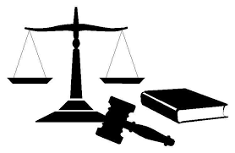
The Trial of Officer Jack Smith of the British Royal Marines will take place on Wednesday 30th of June in the year of our Lord 20__ in Class 6 courtrooms.

Officer Jack Smith is indicted with crimes against The Benin Empire. In that, in February 1897 he did wilfully participate in, authorise and oversee looting and theft of thousands of priceless Benin Bronze plaques and other artefacts.

The court will begin sitting at 10.15am. You are all invited to attend as good citizens of our civilised and united world.

