Queen Mother Idia at war areas

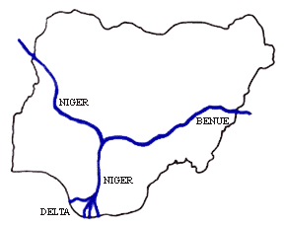

Idah

Benin

Udo

RIVER

RIVER

Ondo