Historical records
History the story of a people’s past tells what happened, when it happened, where it happened and who was involved. A timeline helps us to effectively place events in chronological order.
Keeping a record
Through time people have kept records of their own story using different mediums including; written methods, architecture, metal works, the arts like painting, stone and marble sculpturing, wood and ivory carving, weaving and tapestry, oral story telling passed down through generations and most recently photography.
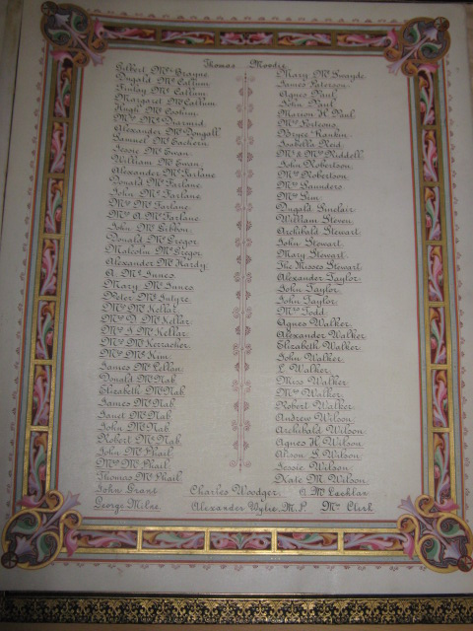 Written records
Architecture
Bronze sculpture of a Scottish soldier 1902 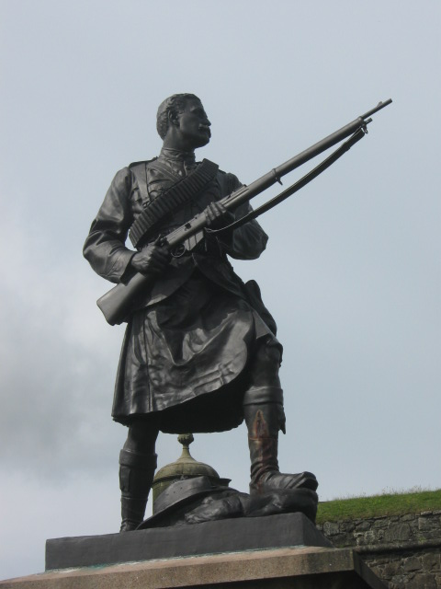
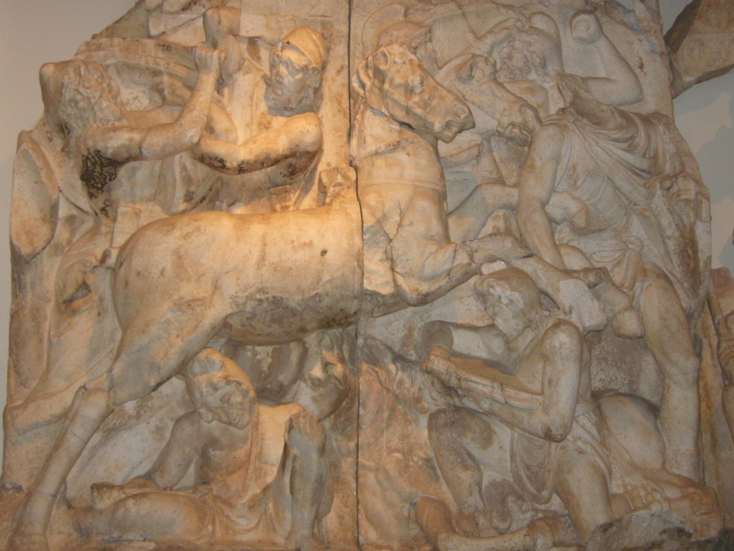
Marble frieze of Roman war with the Parthians (58BC – 217AD)
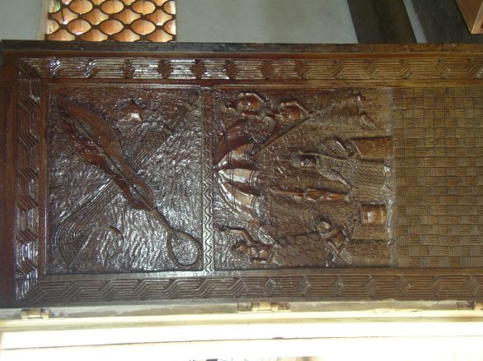 Oba of Benin on carved door
How a particular people and culture choose to record their history and story will depend on availability of materials to do so. In the medieval times for example, Europe used mainly writing, weaving and tapestry, stone and marble sculpturing and wood carving. In the C18, Baroque painting was used and most recently in the C20, photography is widely used. Available materials of the time are used.
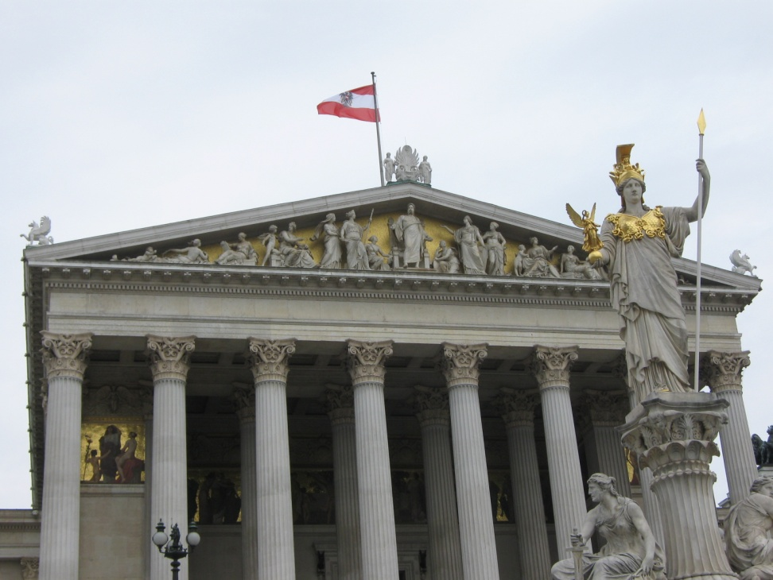 Marble sculpture of Goddess Athena – Parlment Vienna Austria

Baroque painting 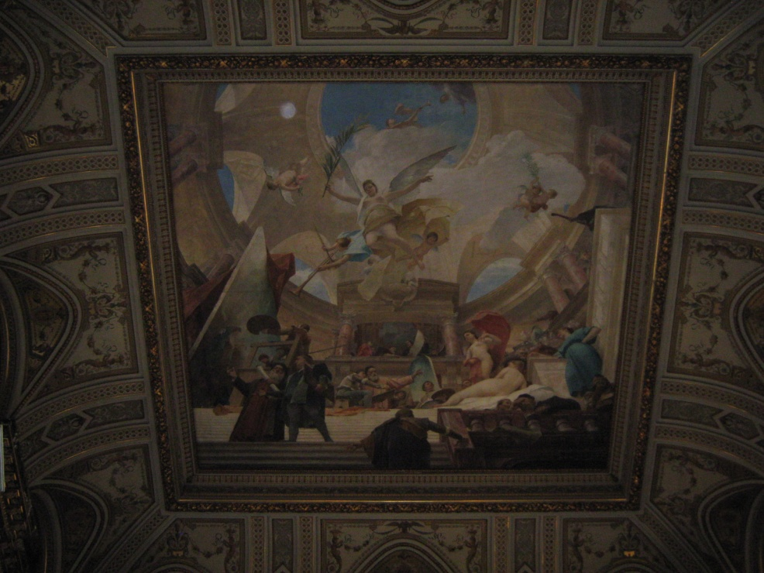
All cultures and peoples in modern times have added photography to all other methods that they use to record their history. This has been made possible by the advancement of technology. The mobile phone with camera is available to everyone. The result is photography history is within everyone’s reach. The recent trend of ‘selfie’ demonstrates how anyone can place themselves in any event and be recorded as part of it. In paintings commissioned by rich people in the past, the artists sometimes painted themselves in the scene or added their signature to achieve the same aim.
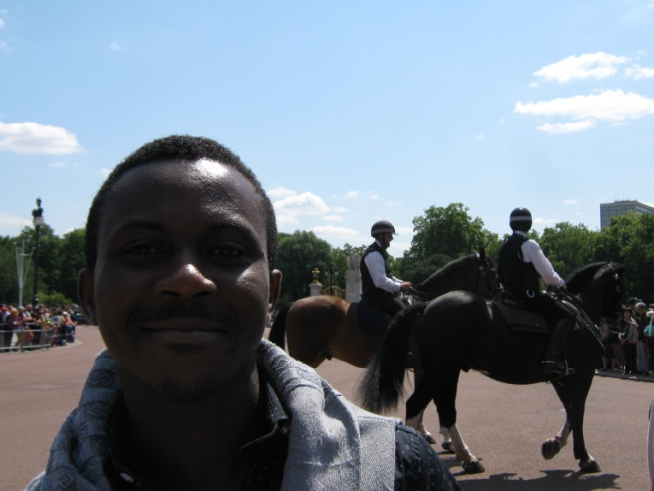 A tourist selfie at Buckingham Palace
A tourist selfie on London Buses 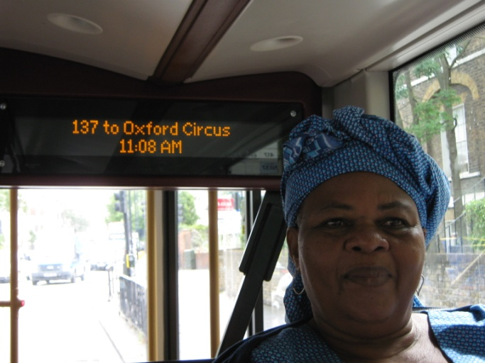
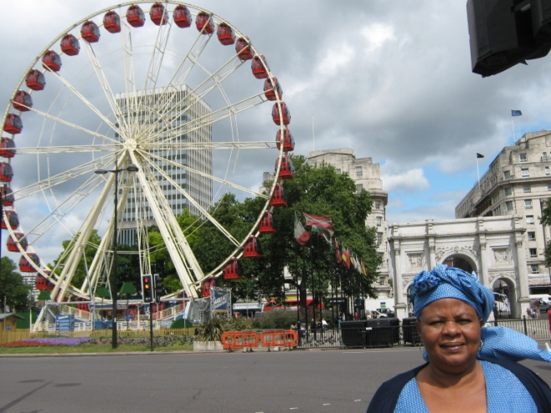 Tourist selfie at Marble Arch London
Kingdom of Benin historical methods
Royalty and Nobility
The king (Oba) commissioned expensive bronze plaques, wood and ivory carving and terracotta to record court activities and achievements.
Bronze plaques were particularly expensive as the metal required for them were obtained from international trade with Europeans in the form of bronze manillas. These then had to be melted down by the artists to produce the bronze plaques.
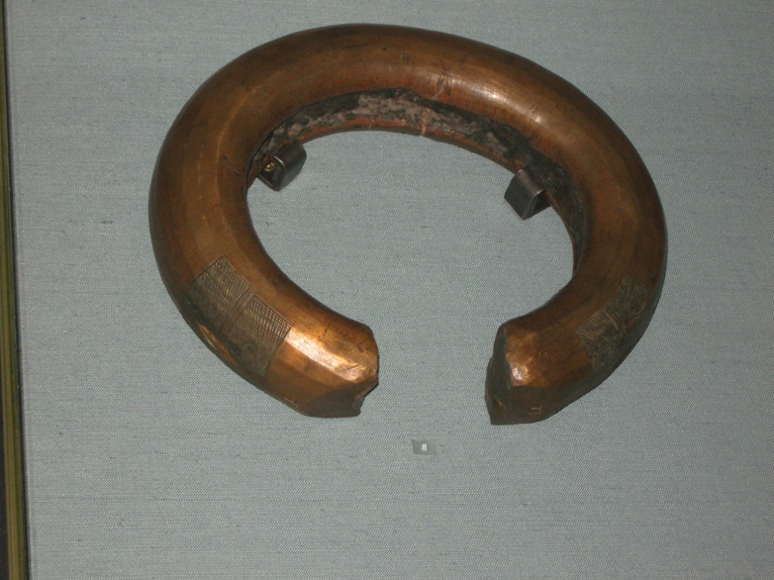 A manilla ring

All royalty and nobility commissioned bronze works, wood and ivory carving and terracotta to record their own personal and family stories.
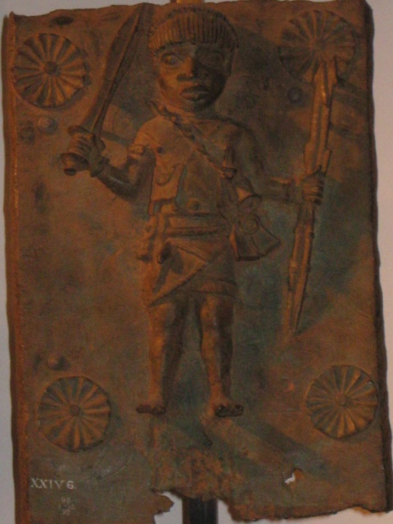 A Benin bronze plaque (British Museum)
Commoners
Commoners without the means to use these expensive methods composed stories of their family and community major achievements through oral story telling. The stories included important details and facts of what happened, who was involved, when and how it happened. In effect, stories were composed of achievements of local heroes and celebrities. Through generations these remained local role models that the next generations could model themselves on. New babies were named after them and frequently they grew up to aspire to the greatness associated with their names.
Through oral storytelling, historical facts were passed down through generations. In this system, an event can be accurately dated and placed on a time line by linking it to other local and world events of the time. Names of characters also give a clue about world events at the time. Their actions and activities give further clues about timeline as acceptable behaviours change over time. Historical periods cover time of mythological beliefs, exploration and technological advancement. Roughly, a character that fights a mythical spirit of the forest can be placed on the world timeline as the same period when people in Europe believed in St George and the Dragon story. An acclaimed bronze caster who smiths a lorry key from memory can be placed in early 1900s.
St George and the Dragon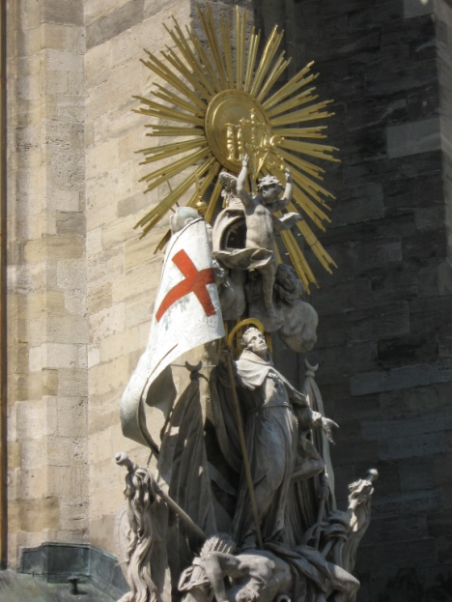
Thus the Kingdom of Benin history was very comprehensive in that all its people’s stories were told or recorded in one way or the other.
Did you know? In the C16, European nobility believed having image of a Moor (North African) brought them good luck.
Here is the head of a Moor on a rapier which belonged to Austrian nobility. It was intended as a fashion item and not as a fighting weapon. It is the head of a West African and not of a North African. However as both West Africans and North Africans lived in North Africa at the time, they did not distinguish between them and called them all Moors.
