Kingdom of Benin Oba with his chiefs and Egyptian Pharaoh in sitting
Compare and contrast the two sculptures below (make notes of your observations to feed back to the class):
- What similarities can you see between them?
- What differences can you see between them?

Oba of Benin in sitting  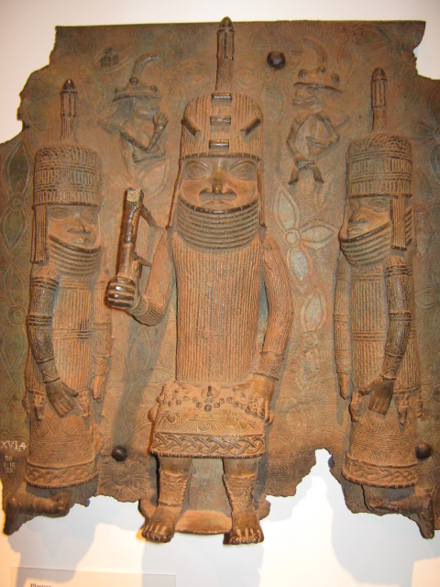 | Pharaoh of Egypt in sitting  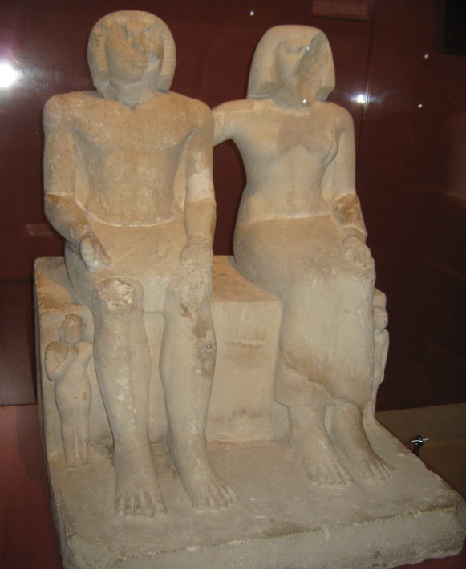
Vocabulary: Oba, chiefs, Portuguese, ceremony, foreign visitors, Pharaoh, Queen, royal children, stone statue, bronze plaque.

