Benin Civilisation study - Design and Technology

What did the Benin people do for fashion?
AIM: to enable pupils to develop the creative, technical and practical expertise needed to perform everyday tasks confidently.
Project: Fashion accessory product
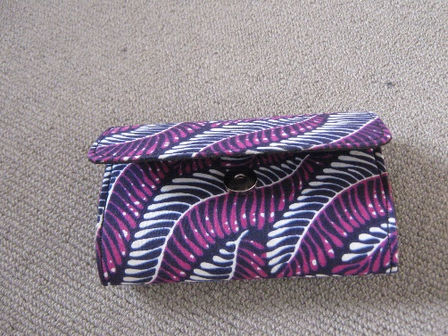
Learning objectives:
Design
To generate, develop, model and communicate their ideas through discussion, annotated sketches and models.
Make
To select from and use a wider range of tools and equipment to perform practical tasks [for example, cutting, shaping, joining and finishing], accurately.
To select from and use a wider range of materials and components, including textiles according to their functional properties and aesthetic qualities.
Evaluate
To investigate and analyse a range of existing products.
To evaluate their ideas and products against their own design criteria and consider the views of others to improve their work.
Technical knowledge
To apply their understanding of how to strengthen, stiffen and reinforce their product.
Resources
Sewing thread
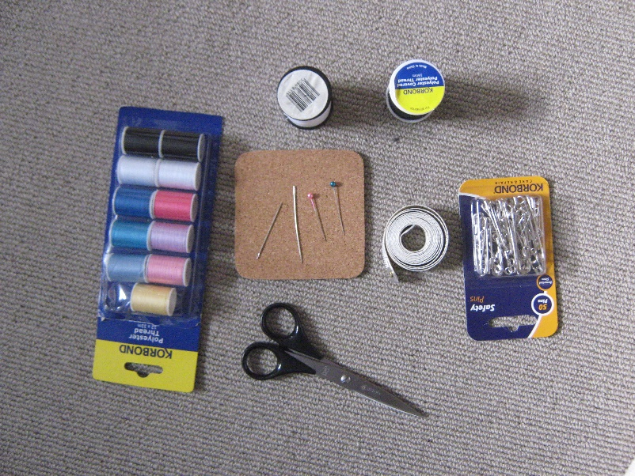
Glass head pins
Various sized needles
Scissors, measuring tape
African fabric
Stiffener e.g. card (optional)
Sewing machine (optional)
Disappearing ink of white chalk for marking (optional)
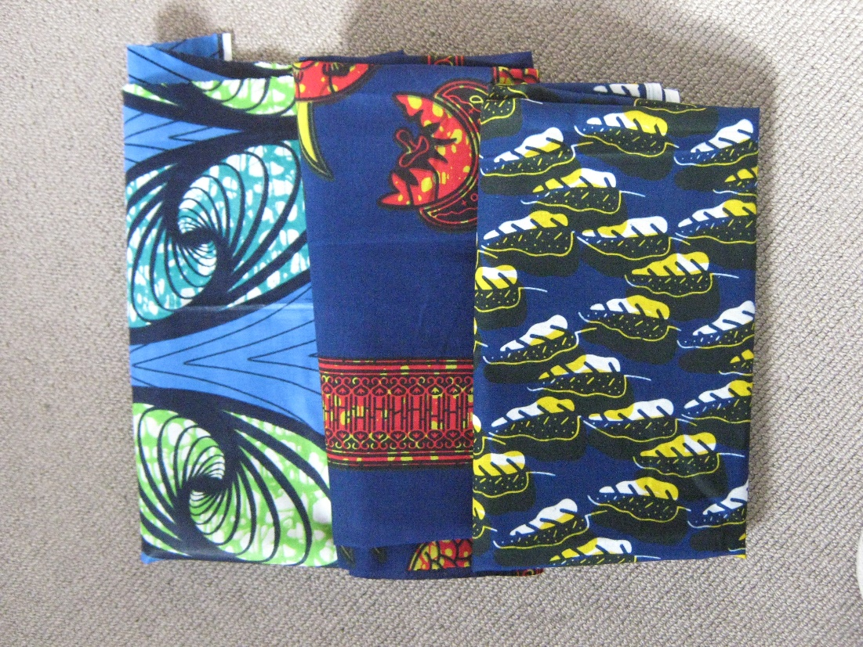

Sewing materials can be purchased from local supermarkets. Fabric can be bought from local markets or fabric shops. Alternatively buy online.
Curriculum links: This project builds on the children’s previous learning in their art lessons on sewing, knitting and fraying fabric. They get to apply all the skills from those lessons to make design and make a product for a real purpose.
Teaching input
Write the words: fashion accessory, research, models and product on the IWB.
Ask what do these words mean? Discuss and tell the class that they will be doing these to produce a fashion accessory using fabric. Ask, ‘Who can tell me what skills we will need to help us make a fabric bag or purse?’ Answers should include sewing and stitching. Remind children of taking care with pins and needles.
Steps
Design
Research and show the class real or photographs of fabric bags and purses. Watch YouTube videos on ‘How to …’
Children should select which purse or bag pattern they would like to make.
Next, they make sketches of their product ideas.
They can then make models of their product idea using paper or card.
They measure, cut out and sew their paper model.
Evaluate their models.
In groups or pairs discuss what they like and/or do not like about their model.
Design another model implementing suggestions from evaluation.
Make
This step can be made as simple as the class can cope with or made a little more challenging with scoring and measurement requirements. Try to keep it simple for the less able pupils and more challenging for the abler pupils.
1.Cut out and give each child a rectangular piece of fabric sufficient for their required product size.
2.Ask them to turn this inside out.
3.They should fold their fabric into three. Two equal sized large ones and one smaller one to fold over as cover.

4.Next fold and match the seams of the two larger pieces.

5.Draw lines on one side of the folded pieces to mark where they will sew along on the fabric (close to the seams).
6.Next thread their needles and use running stitches to sew along the marks.
7.When sewing is completed, they should turn their purse right side out. Fold along the edges of the smaller piece and secure with sewing and stitching.
If the school has sewing machines these could be finished with machine sewing.
Evaluate
Children can evaluate their own and others’ finished product:
What is good about this product is:
What could be better about this product is:
Report writing
Children should write a full report on the whole process of designing and making their product.

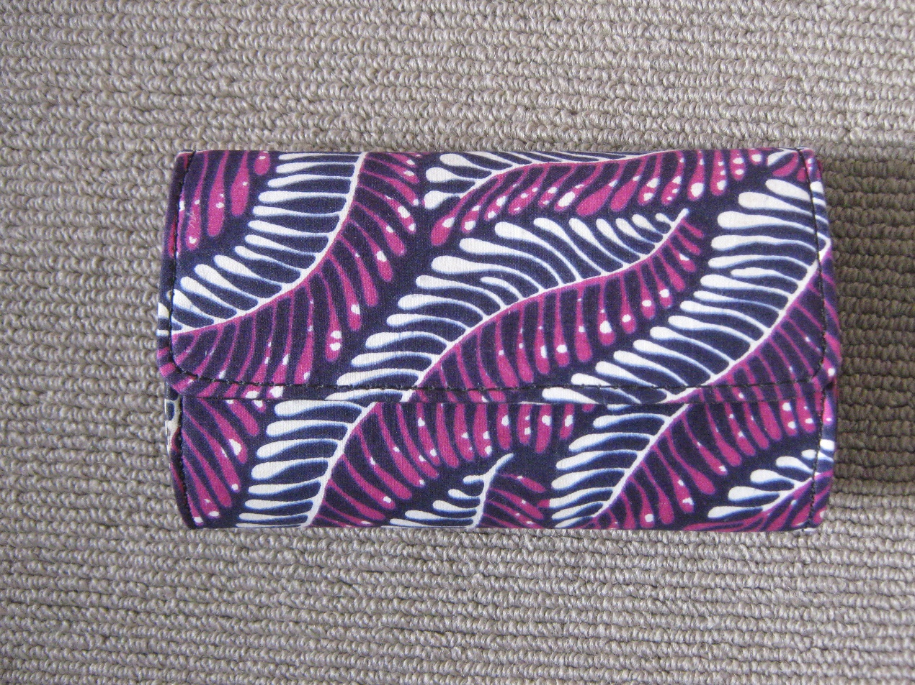
Fabric purse
Uses include:
Personal purse
Pencil case
Phone case
Eye glasses case
Calculator holder
Could be given as a present to friend or family
As many uses as the imagination allows.

