Name ___________________________________ Date __________________
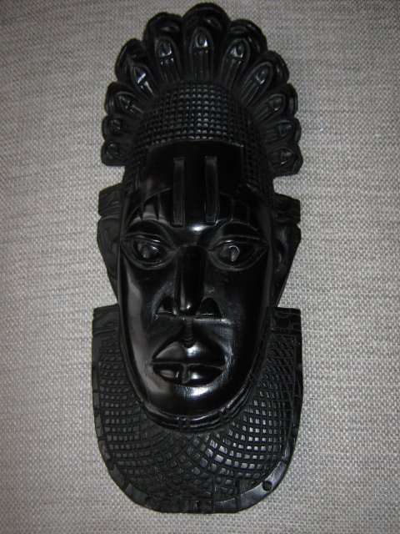

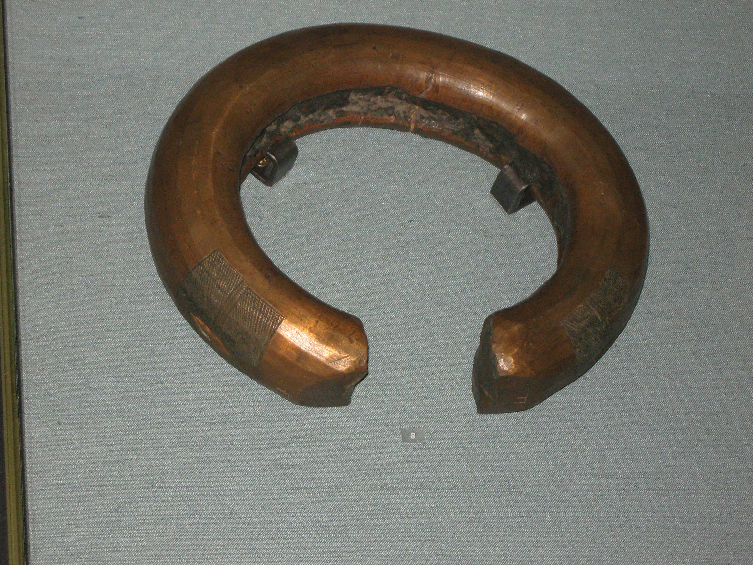

Advertisement

Complete this poster to advertise Kingdom of Benin. You may add any information you like.

